**ANIMATRONICS FACE: Professor Goldie Hood**

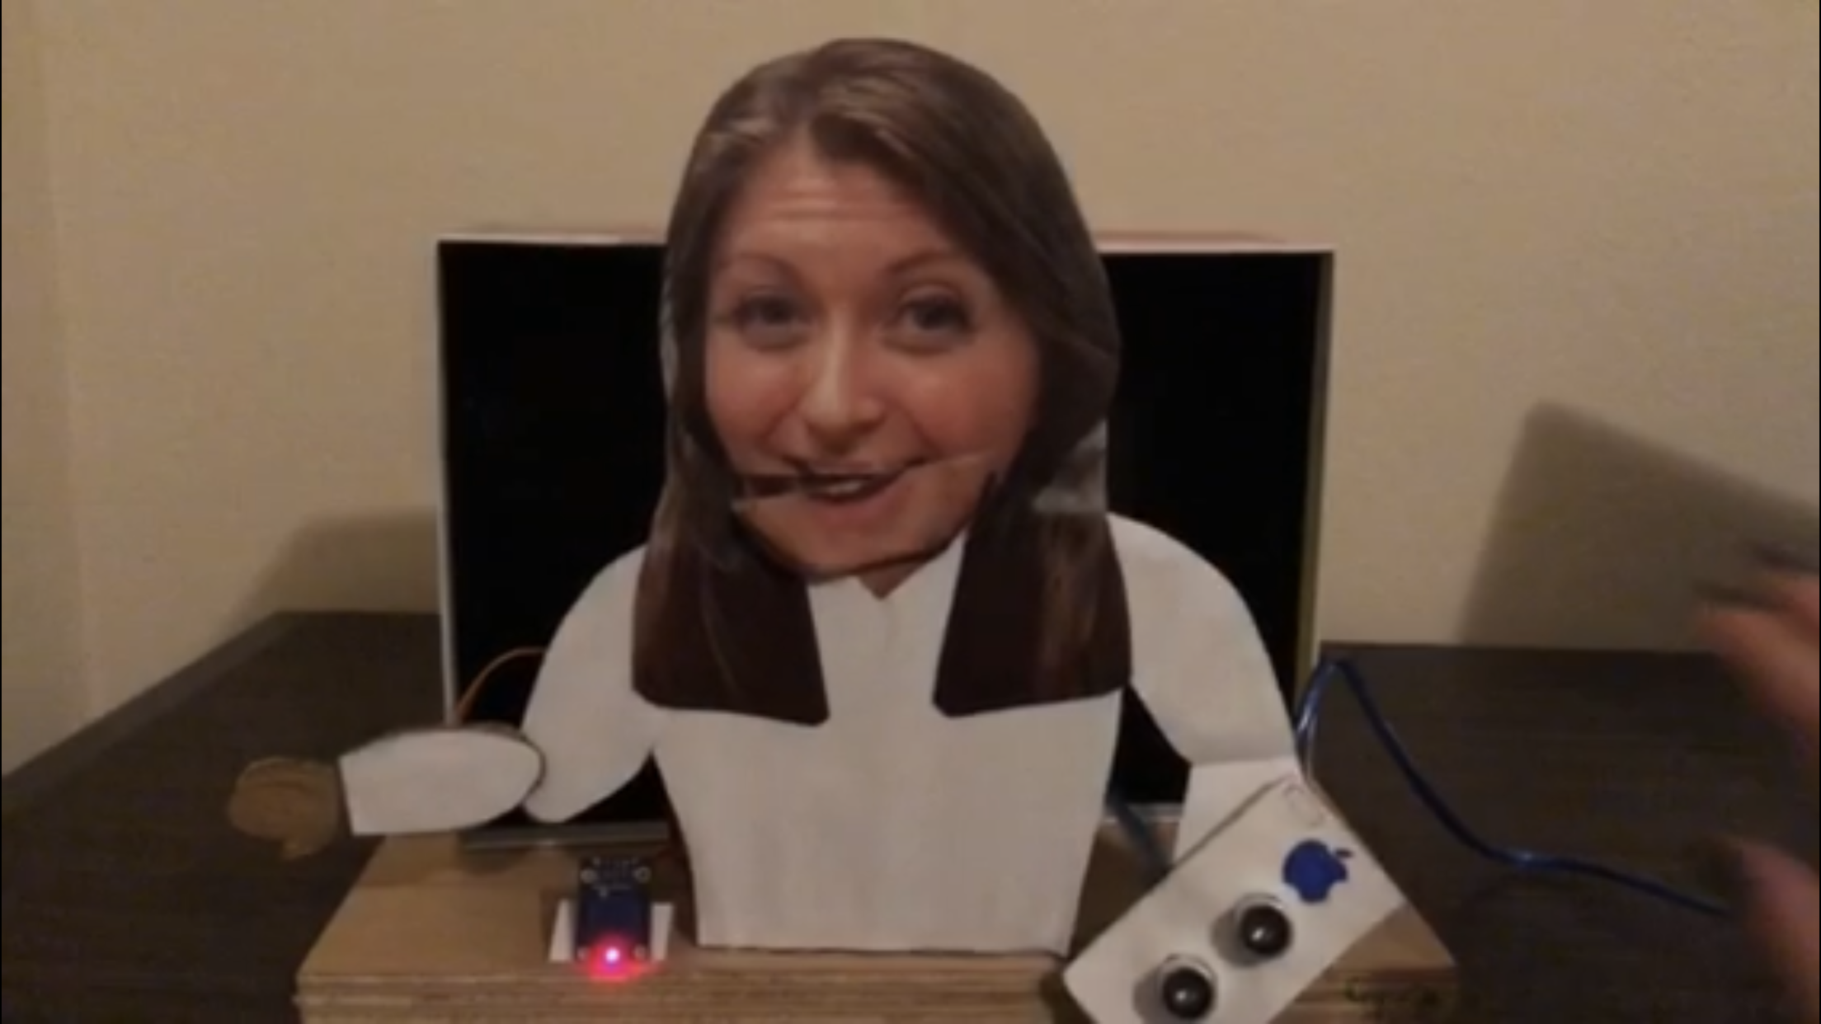

[**https://www.youtube.com/watch?v=bRJwA8lAeQI**](https://www.youtube.com/watch?v=bRJwA8lAeQI)

G’zai Clark

Dept. of Mechanical Engineering

San Antonio, TX, USA 78249

gmn239@my.utsa.edu

Eworitseyomi Mabiaku

Dept. of Mechanical Engineering

San Antonio, TX, USA 78249

[dwg625@my.utsa.edu](mailto:dwg625@my.utsa.edu)

Harper Luczka

Dept. of Mechanical Engineering

San Antonio, TX, USA 78249

[hluczka4@gmail.com](mailto:hluczka4@gmail.com)

Submitted as part of project for ME 4543 Mechatronics, Fall 2018

**TABLE OF CONTENTS**

|  |  |
| --- | --- |
| **Topic** | **Page number** |
| Abstract | 3 |
| Literature review | 4 |
| Brainstorming | 5 |
| Supporting Structure | 6 |
| Joint and motors | 7 |
| Sensors | 9 |
| Programming | 10 |
| Lesson learnt and suggestions | 10 |
| Personnel and Bill of Materials | 11 |
| Acknowledgements | 11 |
| References | 12 |
| Appendix A: Arduino Code | 13 |

**ABSTRACT**

.

In this project we are required to build an animatronic with the face of an assigned professor in which it will have two movements. These movements are to be the mouth and can be one other movement such as the eyes, eyebrows, nose, or anything else that is creative. The movements must function by two different sensors. Along with the sensors, a voice recording has the option to be integrated into the code from Professor Hood that was assigned to us. The group was able to create two codes that controlled two motors with two sensors that moved the mouth with a servo from an ultrasonic sensor and moved the arm with a servo controlled by a touch sensor toggle.

**Section 1: Literature review**

For the first animatronics face discovered, we found the Wall-E Robot as shown in Figure 1 below [3]. The face was created to represent the popular Disney robot Wall-E from the film “Wall-E” that was released back in 2008.The animatronic was created utilizing an Arduino. The creator used a pair of Mattracks for motive power (main drive unit) and two robosapien V2 hip motors with bevel hex gears for the robot’s movement. The robot was then be controlled by a BS2P40 stamp CPU. An H-bridge was designed for the motors using a L298 chip. The eyes would light up by using a circuit that has a CDS cell that would power 6 LED blue lights in the eyes when the lights were switched.

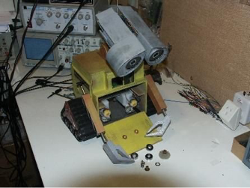

*Figure 1*: Wall-E Robot

The second animatronics face creation that we found was created by ‘Sandro’s Animatronic Workshop’ to create a talking cartoon skull. As seen in reference [4], the animatronic was created utilizing an Arduino UNO, relay board, 12V solenoid, 12V power supply, carton and paper to power the animatronic. The instructions show that they used a solenoid that would be connected to the power supply and through the Arduino relay as well. The creator also provided steps for the Arduino code [5]. The purpose of the animatronic was to create an animatronic for under $50.

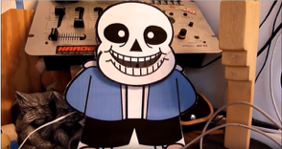

*Figure 2:* $50 Animatronic

The third animatronics face creation that we found was created by ‘mik3’ to create a Halloween animatronic. Their purpose was to create a more realistic animatronic. This was made by using RC servos, USB servo controller, and audacity to record the data as showed in [6]. Then it takes you step by step to set up an animatronic that can move both the eyes and mouth with audio. It was also connected to a 5-volt power supply to the servo controller. The purpose is to create a more realistic animatronic which is more complicated in making that involves taking apart the skull and inputting the controls inside the skull.

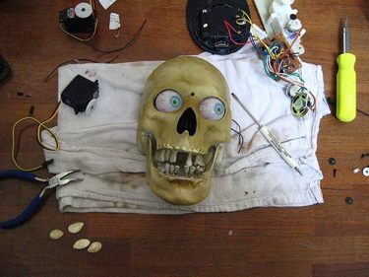

*Figure 3*. Skull Animatronic Face

**Section 2: Brainstorming (initial planning)**

For our animatronic face, we wanted it to be capable of moving its mouth as a representation of the figure being able to talk. While its mouth is moving, we want it to be able to play the soundtrack of Professor Goldie that was assigned to us. In order to move the mouth part, we will be using a servo motor which we will connect to the backside of the head as the grounding support with the actual mouthpiece attached separately to the moving part of the servo. We would then connect a range sensor that would detect movement within 10 inches and open the mouth which should play the soundtrack at the same time. The other sensor would be a contact sensor that would trigger another movement or saying with the help of servos. To make it simple we will fabricate the animatronic with paper and cardboard and put a place where we can make a face while the body made could cover up to hold the solenoid. The Arduino, servos, motors, and sensors should be powered by a 12V supply. Lastly, when we meet with our professor, we plan to record them saying something that would allow us to set it up to sync with the mouth on our animatronic.

**Section 3: Supporting structure**

In the pictures shown, we used the cardboard to cut the face and moving hand of which we will use to have as the movable parts. The hot glue will be used to stick together the sensors or motors that will be attached to the back of our animatronic and to attach the picture to the cardboard cutout. The wood will be our base and L brackets to be possibly attached to the base. Lastly in Figure 7, the cardboard cutout of the body is shown. This excludes all moving parts of the face with just the supporting structure.

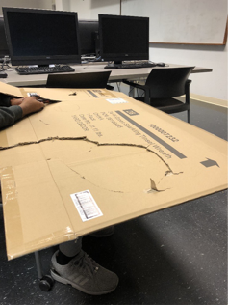

*Figure 4.* Cardboard used for Supporting Structure

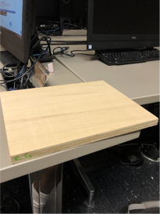

*Figure 5.* Wood for Structural Base

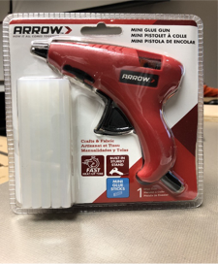

*Figure 6.* Hot Glue for Attaching

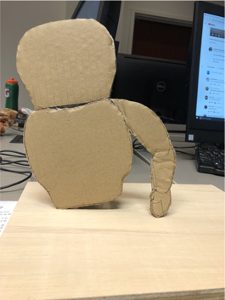

*Figure 7.*  Supporting Structure minus moving parts

**Section 4: Joints and motors**

The joints we selected where the mouth joint which will be activated when the ultrasonic sensor reads a certain distance which will activate the mouth and the sound of the voice to go along with it. The servo works as a simple up and down at 45 to 90 degrees which can mimic a person speaking if we attached the jaw piece to it making for a easier voice representation. The touch sensor will activate the elbow joint which will wave when this by a servo motor. We chose the servo for its ability to turn up to 180 degrees which when someone waves, portrays their natural movement. The figure below shows the circuitry set up behind the actual face. It includes one breadboard and the Arduino UNO, along with the two servos, ultrasonic sensor, and the touch sensor.

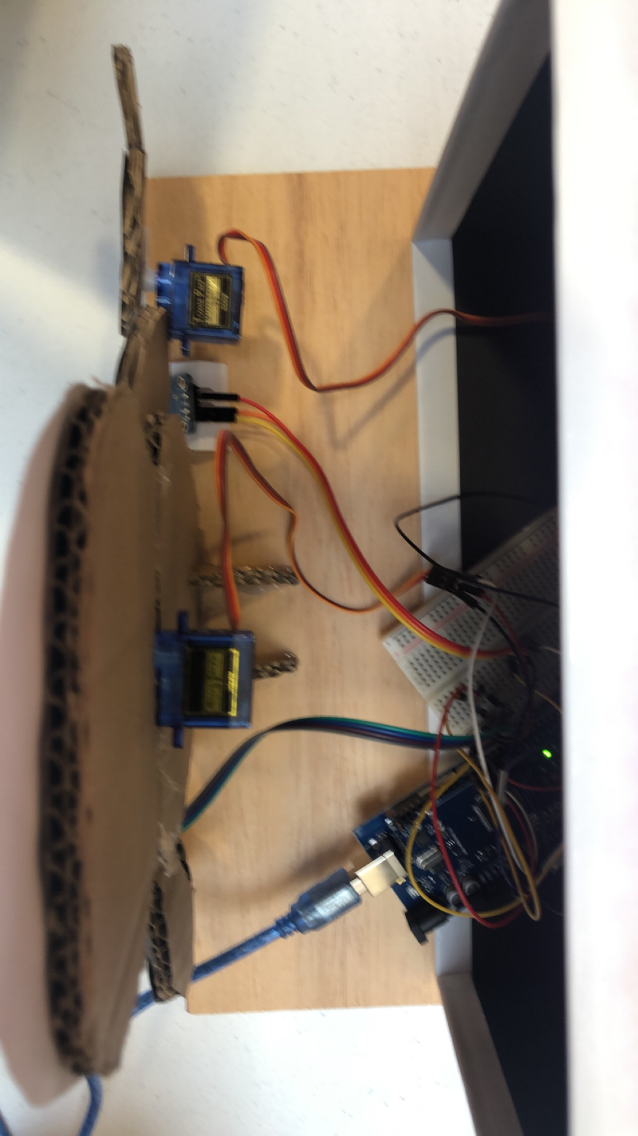

*Figure 8.* Setup of Circuitry

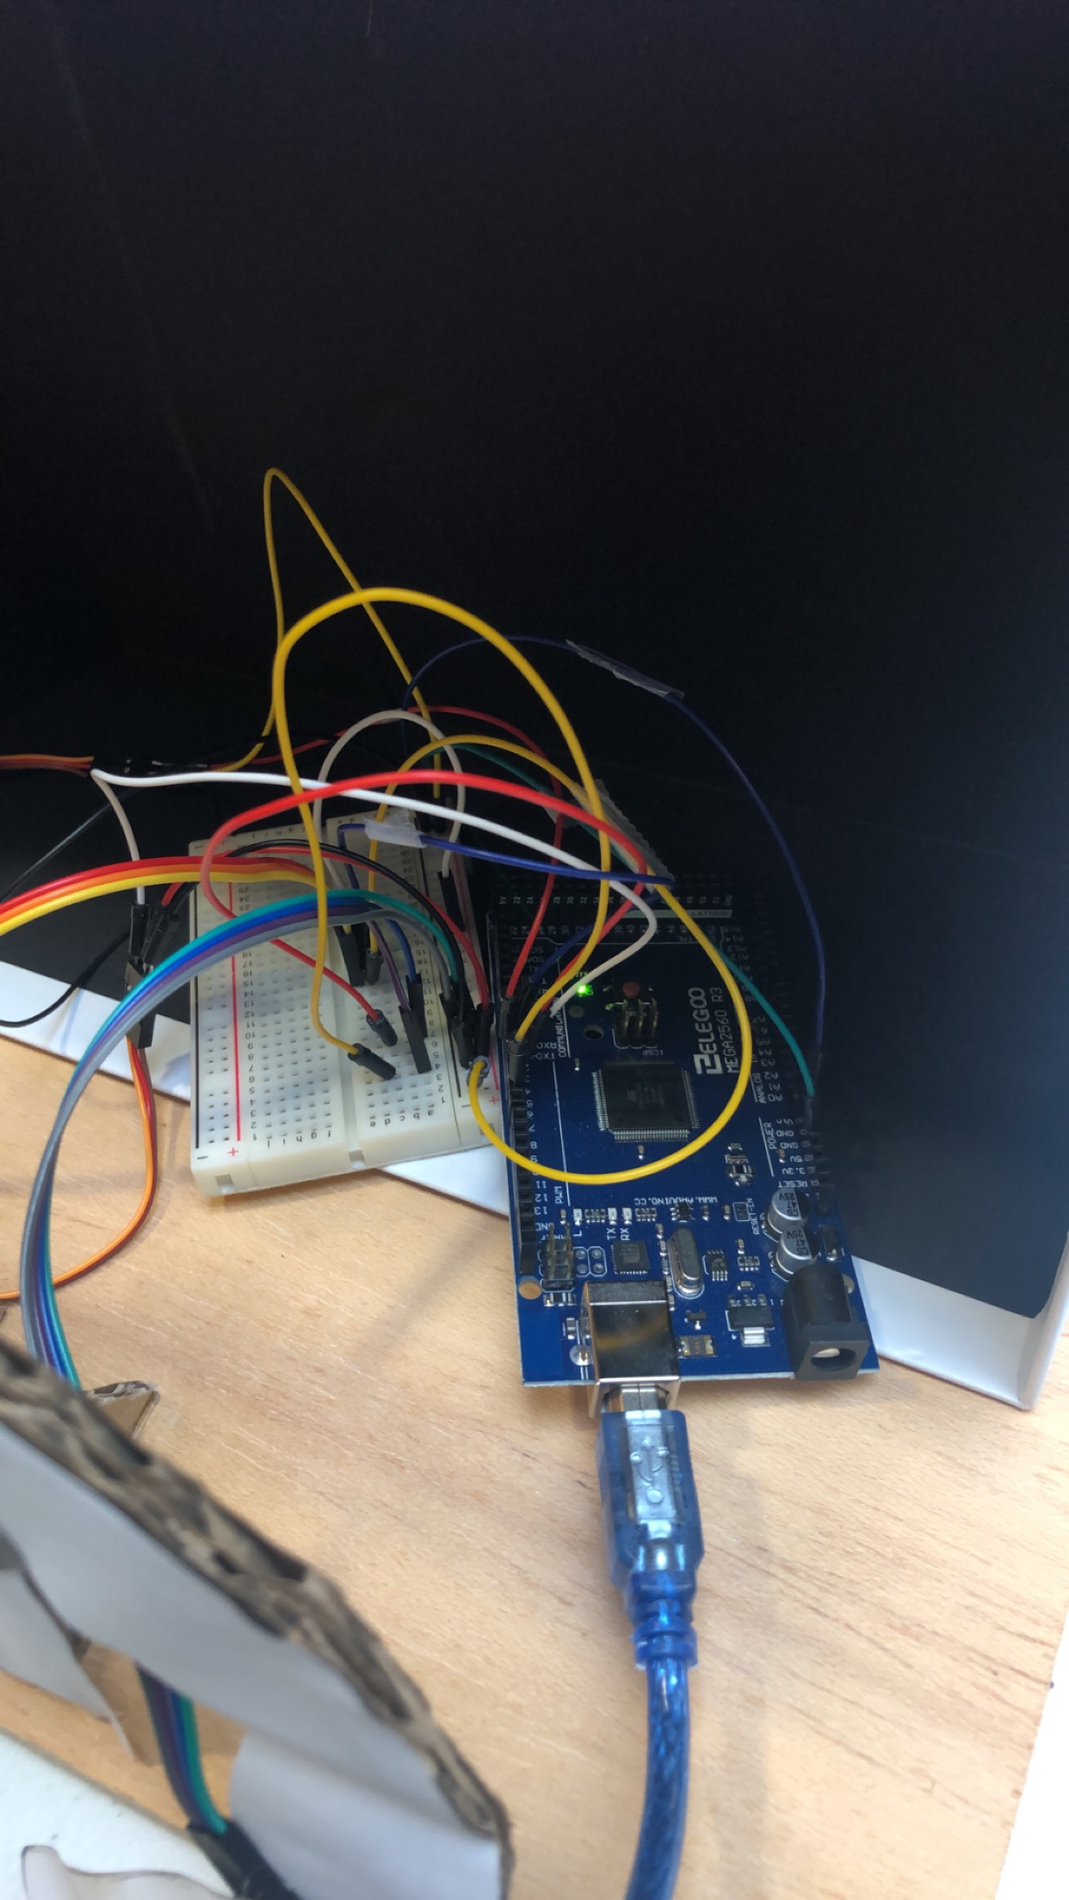

*Figure 9.* Alternate View of Circuitry Setup

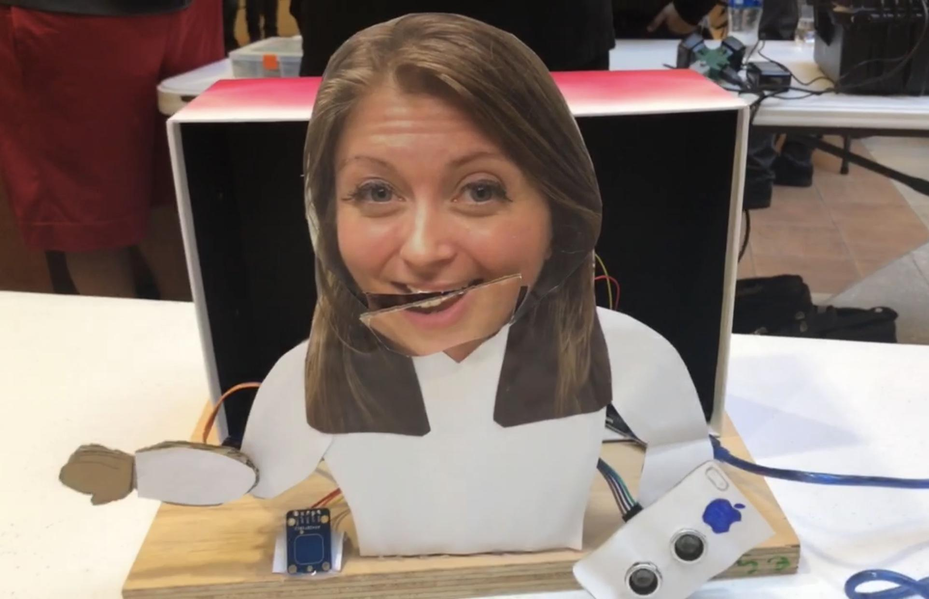

*Figure 10.* Close up of Elbow Joint and Touch Sensor



*Figure 11.* Close up of Mouth and Ultrasonic Sensor

**Section 5: Sensors**

The touch sensor was the sensor we chose to use because it was just like a toggle on-off switch. When touched, it would turn on and activate the motor giving us the ability to make a waving motion with the servo, and when touched again it would stop the waving motion. The ultrasonic sensor was chosen because we have worked with it in previous labs and have one already in the Arduino kit. It works at measuring by emitting sound waves at a frequency then wait for the sound to be reflected back, calculating distance based on the time required to it to return. We set the distance to be 10 inches. Once inside that distance range, the servo would be activated for the mouth.

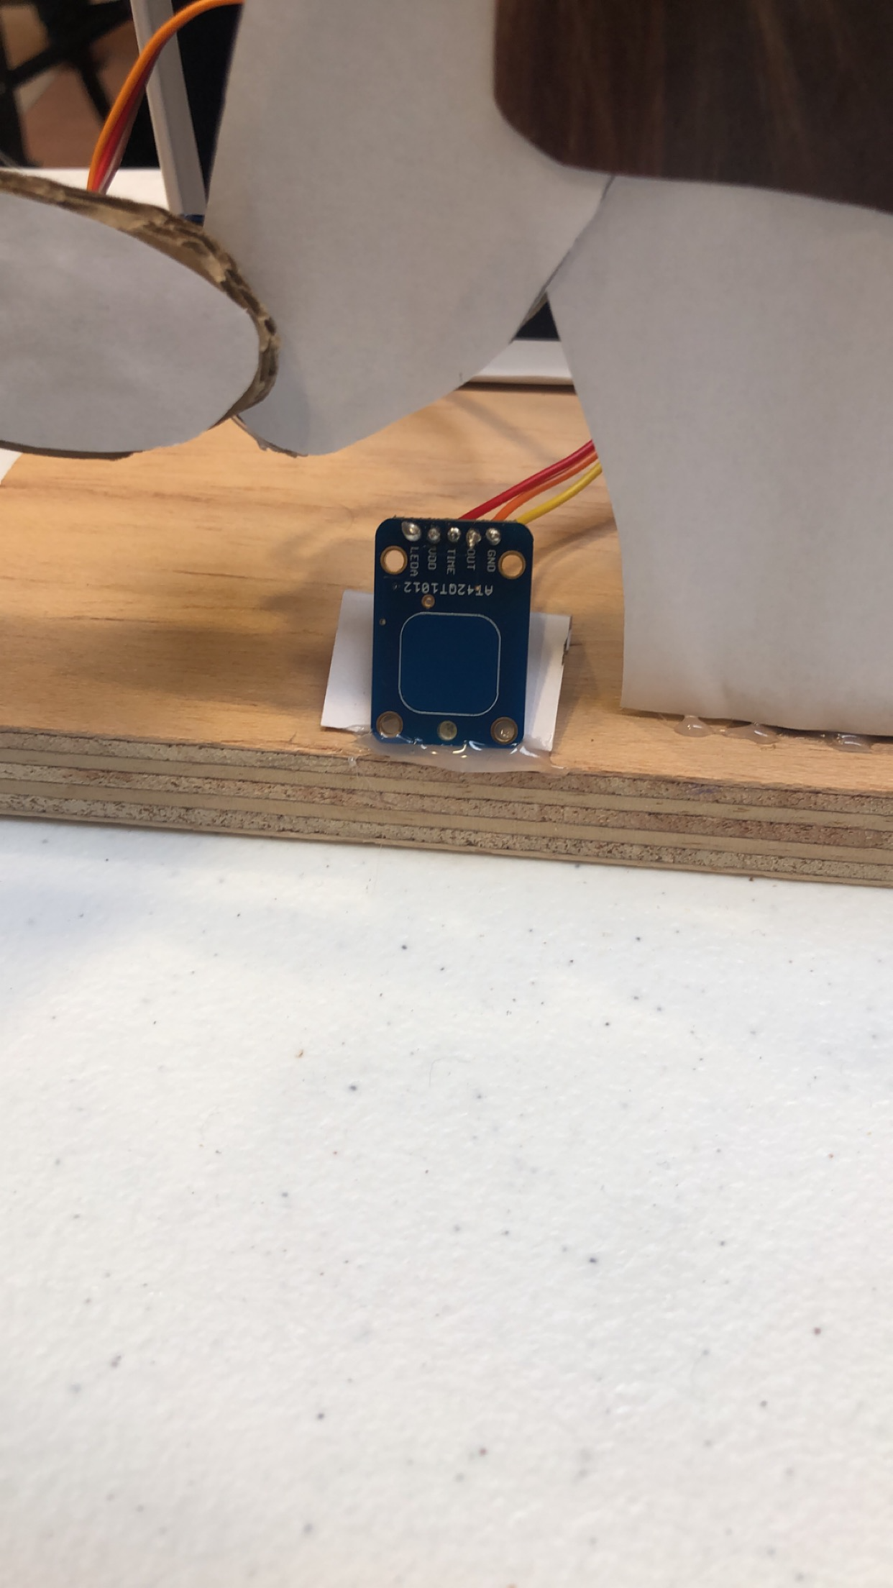

*Figure 12.* Touch Sensor

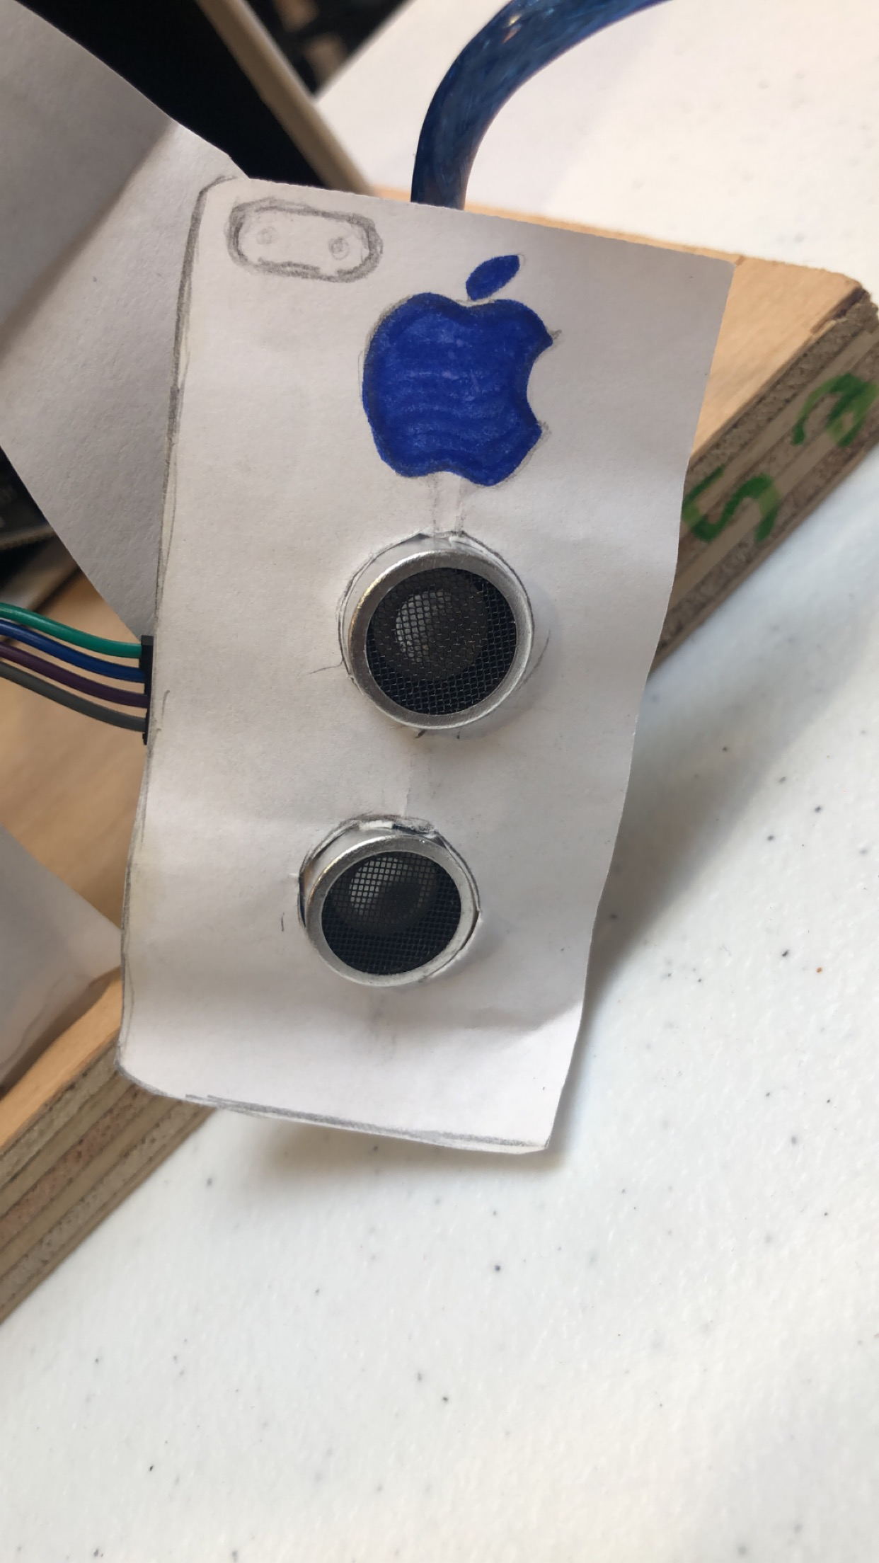

*Figure 13.* Ultrasonic Sensor Disguised as Phone

**Section 6: Programming for interaction**

**Code Ultrasonic:**

Since we have some background in working with ultrasonic sensors, this was one device we wanted to use. Our background included having the ultrasonic measure distance measurements by a code, so we could change the code up to make another sensor up with the distance. Within 10 inches, the sensor will make the servo motor move the mouth to mimic speaking.

**Code Touch Sensor:**

First, we needed to have two inlets one for both the sensor and the servo motor. The breadboard needed to be given power as well as a ground. The main function of the servo we want it to turn to mimic a waving motion so put in servo1.write(degree angle) to do this in the loop section. For the touch sensor part we would put pinned as ledpin was output and touchpin as the input as the setup. Doing these with some other coding will make our touch sensor word to function simultaneously as our servo. The link for our project is located on our title page for further explanation.

The full code is in the appendix.

**Section 7: Lessons learnt and suggestions (1 page)**

Lesson Learned:

1. Integrating the touch sensor to work with Arduino. Had to solder the pins into the touch sensor then find the code with the servo motor to work simultaneously. Pick a sensor that already has pins or a easier sensor with a code already found for it.
2. Getting the codes to work together since we used common ports. Easy fix was looking at each other codes and changing the numbers up so they both can work together.
3. Also learned that the delay function cannot be used when trying to simultaneously run two different codes. This was a barrier that had to be worked around for the Arduino.

Suggestions on Improvement:

1. Our original idea was to use a solenoid for the mouth. However, halfway through, we found that we couldn’t supply enough power with the diodes we had, so we switched to a second servo for the mouth. This explains why our mouth moves side to side instead of up in down. So in the future, I would plan ahead in fixing the mouth.
2. Secondly, I would get a better understanding of the millis() program. We couldn’t fully use that code in replace of our delay function, so we had to keep the delay to allow our program to fully function.

**Section 8: Personnel and bill of materials**

**(a) Personnel**

|  |  |  |
| --- | --- | --- |
| **Task** | **Main personal** | **Secondary personal** |
| Touch Sensor | G’zai | Yomi |
| Ultrasonic sensor | Harper | G’zai |
| Voice integration | Yomi | G’zai |
| Structure | Harper | Yomi |

**(b) Bill of materials**

|  |  |  |  |  |  |
| --- | --- | --- | --- | --- | --- |
| **No.** | **Description** | **Website/comment** | **Qty.** | **Unit $** | **Total $** |
| **1** | **Arduino Mega 2560** | **Provided** | **1** |  |  |
| **2** | **Small stepper motor** | **sparkfun.com** | **1** | **6.95** | **6.95** |
| **3** | **Wood/cardboard/hot glue** | **scrap** | **1** | **8** | **8** |
| **4** | **Touch sensor** | **amazon** | **1** | **5.95** | **5.95** |

Total price for this project was around $20 for the motor, touch sensor, and the parts that made the animatronic.

**Acknowledgements**

Special thanks to Dr. Hood for taking the time out of her busy schedule to allow us to take a picture and record her voice.

**References:**

[1]Animatronics Face of UTSA's President, Dr. Ricardo Romo,<https://youtu.be/xkze1_hnam0>

[2] ROMOBOT - ANIMATRONIC FACE ROBOT

<https://www.instructables.com/id/RomoBOT-Animatronic-Face-Robot/>

[3] Intro: Wall-E Robot

<https://www.instructables.com/id/Wall-E-Robot/>

[4] How to Build an Animatronic Under 50$

<https://www.youtube.com/watch?v=WgFJI0CajJA>

[5] Arduino Light Display With Vixen

<https://www.instructables.com/id/Arduino-Light-Display-With-Vixen/>

[6] Halloween Animatronics

<https://www.instructables.com/id/Halloween-Animatronics/>

[7] Touch sensor with coin

<https://www.hackster.io/amalmathewtech/touch-controlled-light-using-arduino-d2f878>

<https://www.hackster.io/techno_z/arduino-sensors-led-buzzer-touch-sensor-a0a999>

<https://www.instructables.com/id/Tree-of-Life/>

<https://learn.adafruit.com/adafruit-capacitive-touch-sensor-breakouts/overview> *

[8] Gold animatronic of our group

<https://www.youtube.com/watch?v=bRJwA8lAeQI>

**Appendix A: Arduino Code**

#define touchPin 2

#include <Servo.h> //include servo pin

#define trigPin 5

int ledPin = 13;

int echoPin = 6;

int servoControlPin = 4;

float pingTime;

float targetDistance;

float speedOfSound = 776.5;

float servoAngle;

int servoPin = 3;

// Create a servo object

Servo Servo1;

Servo Servo2;

void setup()

{

Serial.begin(9600);

pinMode(ledPin, OUTPUT);

pinMode(touchPin, INPUT);

pinMode(trigPin, OUTPUT);

pinMode(echoPin, INPUT);

Servo2.attach(servoControlPin);

Servo1.attach(servoPin);

}

void loop()

{

togglesensor ();

//ultrasonic ();

}

void togglesensor ()

{

Servo2.write(50);

int touchValue = digitalRead(touchPin);

if (touchValue == HIGH)

{

Servo1.write(0);

delay(350); // Make servo go to 90 degrees

Servo1.write(90);

delay(350); // Make servo go to 180 degrees

Servo1.write(180);

delay(350);

}

else

{

digitalWrite(ledPin, LOW);

Servo1.write(90);

}

}

void ultrasonic ()

{

// ultrasonic and servo

digitalWrite(trigPin, LOW);

delayMicroseconds(20);

digitalWrite(trigPin, HIGH);

delayMicroseconds(15);

digitalWrite(trigPin, LOW);

delayMicroseconds(10);

pingTime = pulseIn(echoPin, HIGH);

pingTime = pingTime/1000000; // convert time to seconds

pingTime = pingTime/3600; //convert time to hours

targetDistance = speedOfSound*pingTime; //miles

targetDistance = targetDistance/2;

targetDistance = targetDistance*63360; //convert miles to inche

if(targetDistance <= 10)

{

Servo2.write(0); //full speed to right

delay(200);

Servo2.write(50);

delay(200);

Servo2.write(0); //full speed to right

delay(200);

Servo2.write(45);

delay(200);

Servo2.write(0); //full speed to right

delay(200);

Servo2.write(50);

}

else

{

digitalWrite(trigPin, LOW);

Servo2.write(50);

delay(2000);

}

Serial.print("Distance to Target: ");

Serial.print(targetDistance);

Serial.println("inches");

servoAngle = (106./7.)*targetDistance+37; //servo angle from distance

Servo2.write(servoAngle);

Serial.println(servoAngle);

delay(100);

}